# Overview

This document contains information on the design of the Adaptive Utensils, a set of adjustable and interchangeable 3D printed adaptive utensil handles.

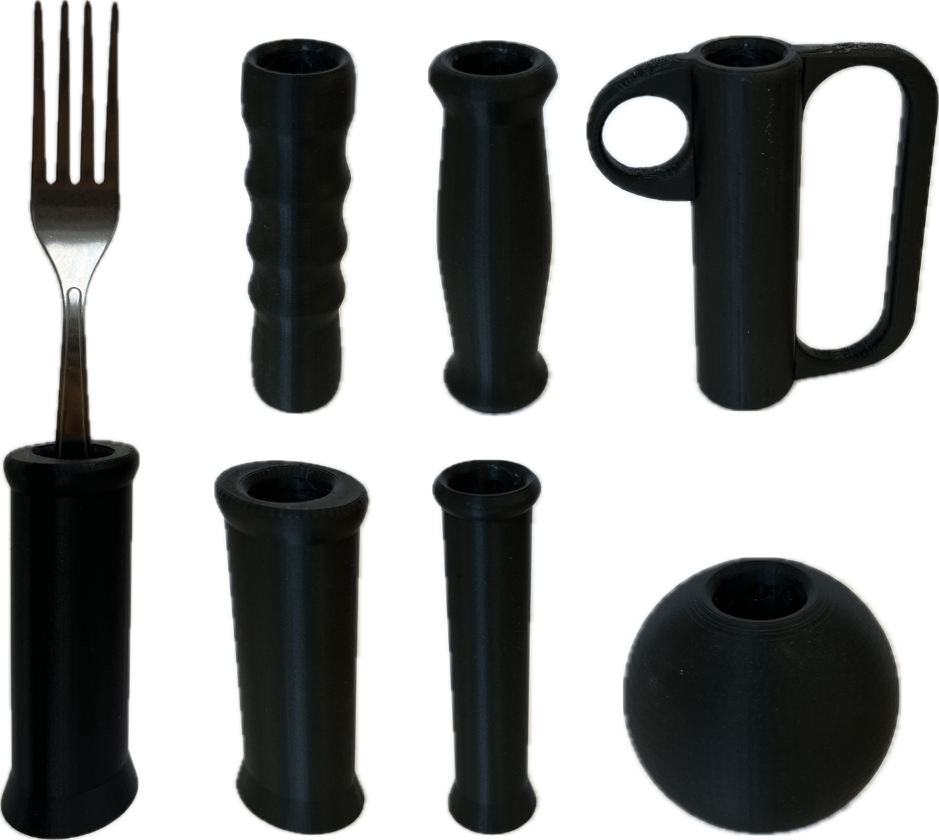

Contents

Completion Checklist (DELETE BEFORE POSTING) **Error! Bookmark not defined.**

Overview 1

Introduction 3

Requirements 3

Research 4

Commercially Available Options 4

Special Supplies Adaptive Utensils 4

Vincere Silverware Weighted Utensils 5

Special Supplies Bendable Adaptive Utensils 5

DIY / Maker Friendly Options 6

Fork and Spoon Support 6

Working Notes 8

# Introduction

Commercially available adaptive utensils are expensive commitments where buyers are unable to trial different styles of handles and determine what best suits their needs. Some purchased sets cannot be returned, which may leave individuals with adaptive utensils that are uncomfortable to use.

The 3D printed Adaptive Utensils play the same role as commercially available adaptive utensils, which is to allow individuals with poor fine motor control to eat independently. However, the 3D printed handles fulfill a different niche in how they are fast and cheap to manufacture, which lowers the barrier-to-entry and lets individuals trial different handle shapes to develop their own preference. Afterwards, users may 3D print more of their preferred handle or purchase a similar commercial adaptive utensil set for long-term usage.

The 3D printed Adaptive Utensils are for individuals who struggle to grasp and manipulate utensils. The affected patient population includes weakness in arm or grip strength, tremors/shakiness, limited range of motion, and poor fine motor skills.

# Requirements

* Handles must be significantly larger than a typical utensil handle and feel ergonomic to hold to reduce the strain on fingers
* Must be compatible with at least a spoon and fork.
* There should be as few components as possible to reduce the risk of misplacing them
* Handles should be simple and quick to order/manufacture
* Utensil must be interchangeable with different types of handles
* Adjustable depth for utensil in handle
* Adjustable rotation for utensil in handle
* Utensil must lock in place during regular usage
* Create smooth geometry where possible to improve the overall appearance and feel of the printed handles
* Imitate common shapes for commercial adaptive utensils so users can test those styles before buying them
* Printed handle sets must be cheaper than generic commercial adaptive utensils (maximum $30 CAD per set)
* Use PLA and/or PETG, as they are the most common 3D printing materials

# Research

## Commercially Available Options

### Special Supplies Adaptive Utensils

|  |  |
| --- | --- |
| **Title / Name of device** | Special Supplies Adaptive Utensils (4-Piece Kitchen Set) Wide Non-Weighted Non-Slip Handles for Hand Tremors Arthritis Parkinson's or Elderly use | Stainless Steel Knife Fork Spoons - Grey |
| **Link** | [Amazon Link](https://www.amazon.ca/Adaptive-Utensils-Non-Weighted-Arthritis-Parkinsons/dp/B074JH1T1N/ref=sr_1_27?dib=eyJ2IjoiMSJ9.PJDv_ZfCaUMWVva-WQ0olugQAISz270ZttgC0zVRIEUPbaWm91KhoN17TIkC6lInZaXvbG_51KgkctXPIbHhxGrnxEhV7Je4-uL4ZBbmjpAgnnmIei_QxQQvH58Wgm4aWhyRXKOaK-J4IiLRelmHG7ZU1KJ87vRul5jBZ_ofvw53E8ojedDs4tOcC-UxwwmU3Yai_wui3LA36y6WFVHRgvV47c2JPd6mJLm_S9I0CykyFGstleL030HGCs9uNqFMmJMj4ZHEpk2TZBNQgrUc8Rr6am4_Xs1cREyh53Ht2iY.ywIiCDyRfWxvzh3t0GBs88Ywei4UicXx_3RrFDgwdno&dib_tag=se&qid=1732038735&refinements=p_72%3A11192170011&rnid=11192166011&s=hpc&sr=1-27) |
| **Author** | Brand: Special Supplies. Distributor: Amazon |
| **License** | N/A |
| **Cost** | $35.00 CAD |

Non-weighted adaptive utensils that are dishwasher safe, have stainless-steel utensils, and ribbed silicone handles for improved grip. Each set includes a fork, knife, curved knife, dinner spoon, and soup spoon.

|  |  |
| --- | --- |
| **Requirements Met** | **Requirements Unmet** |
| G01, G02, G03, G04, F04, NF01 | F01, F02, F03, NF02 |

#### Useful Design Features

Utensils are dishwasher safe, which makes cleaning quick and easy.

### Vincere Silverware Weighted Utensils

|  |  |
| --- | --- |
| **Title / Name of device** | Weighted Utensils for Tremors and Parkinsons, Heavy Weight Stainless Steel Silverware Set, Adaptive Eating Flatware Helps Hand Tremors, Parkinsons Aids for Living, Arthritis - Knife, Fork, Spoons, 7oz |
| **Link** | [Amazon Link](https://www.amazon.ca/Weighted-Utensils-Tremors-Parkinsons-Silverware/dp/B07YNSJDW6/ref=sr_1_4?dib=eyJ2IjoiMSJ9.PJDv_ZfCaUMWVva-WQ0olugQAISz270ZttgC0zVRIEUPbaWm91KhoN17TIkC6lInZaXvbG_51KgkctXPIbHhxGrnxEhV7Je4-uL4ZBbmjpAgnnmIei_QxQQvH58Wgm4aWhyRXKOaK-J4IiLRelmHG7ZU1KJ87vRul5jBZ_ofvw53E8ojedDs4tOcC-UxwwmU3Yai_wui3LA36y6WFVHRgvV47c2JPd6mJLm_S9I0CykyFGstleL030HGCs9uNqFMmJMj4ZHEpk2TZBNQgrUc8Rr6am4_Xs1cREyh53Ht2iY.ywIiCDyRfWxvzh3t0GBs88Ywei4UicXx_3RrFDgwdno&dib_tag=se&qid=1732038735&refinements=p_72%3A11192170011&rnid=11192166011&s=hpc&sr=1-4) |
| **Author** | Brand: Vincere Silverware. Distributor: Amazon |
| **License** | N/A |
| **Cost** | $99.95 CAD |

7oz weighted utensils designed to improve stability for individuals with tremors. They are dishwasher safe, but do not have a significantly larger handle like typical adaptive utensils. Each set includes a knife, fork, tablespoon, and soup spoon.

|  |  |
| --- | --- |
| **Requirements Met** | **Requirements Unmet** |
| G02, G03, G04, F04, NF01 | G01, F01, F02, F03, NF02 |

#### Useful Design Features

The weighted design should help reduce shaky hands from tremors.

### Special Supplies Bendable Adaptive Utensils

|  |  |
| --- | --- |
| **Title / Name of device** | Special Supplies Adaptive Utensils (4-Piece Kitchen Set) Wide Weighted Non-Slip Handles for Hand Tremors Arthritis Parkinson‚ or Elderly use | Stainless Steel Knife Fork Spoons (Gray Weighted Bendable) |
| **Link** | [Amazon Link](https://www.amazon.ca/Adaptive-Utensils-Weighted-Arthritis-Parkinsons/dp/B07JCF9HW3/ref=sr_1_16?dib=eyJ2IjoiMSJ9.PJDv_ZfCaUMWVva-WQ0olugQAISz270ZttgC0zVRIEUPbaWm91KhoN17TIkC6lInZaXvbG_51KgkctXPIbHhxGrnxEhV7Je4-uL4ZBbmjpAgnnmIei_QxQQvH58Wgm4aWhyRXKOaK-J4IiLRelmHG7ZU1KJ87vRul5jBZ_ofvw53E8ojedDs4tOcC-UxwwmU3Yai_wui3LA36y6WFVHRgvV47c2JPd6mJLm_S9I0CykyFGstleL030HGCs9uNqFMmJMj4ZHEpk2TZBNQgrUc8Rr6am4_Xs1cREyh53Ht2iY.ywIiCDyRfWxvzh3t0GBs88Ywei4UicXx_3RrFDgwdno&dib_tag=se&qid=1732038735&refinements=p_72%3A11192170011&rnid=11192166011&s=hpc&sr=1-16&th=1) |
| **Author** | Brand: Special Supplies. Distributor: Amazon |
| **License** | N/A |
| **Cost** | $33.40 CAD |

6oz weighted adaptive utensils that are dishwasher safe, have bendable stainless-steel utensils, and ribbed silicone handles for improved grip. Each set includes a fork, knife, dinner spoon, and soup spoon.

|  |  |
| --- | --- |
| **Requirements Met** | **Requirements Unmet** |
| G01, G02, G03, G04, F03, F04, NF01 | F01, F02, NF02 |

#### Useful Design Features

Utensils are bendable for more user customizability.

## DIY / Maker Friendly Options

<Links to and quick descriptions of DIY / maker friendly devices that may meet a user’s needs>

### Fork and Spoon Support

|  |  |
| --- | --- |
| **Title** | **Fork and Spoon Support** |
| **Link** | [Makers Making Change Link](https://www.makersmakingchange.com/s/product/fork-and-spoon-support/01tJR00000068zYYAQ) |
| **Author** | MMC Community |
| **License** | Attribution-NonCommercial-ShareAlike4.0 International |
| **Cost** | $0-$10 CAD |
| **Test Build (Y/N)** | N |
| **Add to Library (Y/N)** | Already Added |

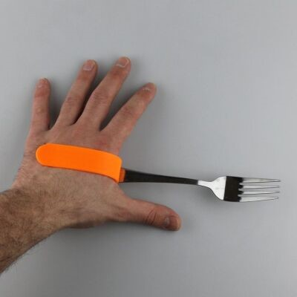

The Fork and Spoon Support allows people with limited grip strength to hold and use eating utensils. Users can slot the device over their palm for a grip-free usage or hold both handles for a larger grip. The slot fits standard sized eating utensils like forks, spoons, and knives.

|  |  |
| --- | --- |
| **Requirements Met** | **Requirements Unmet** |
| G01, G02, G03, G04, F02, F04, NF01 | F01, F03, NF02 |

#### Useful Design Features

Compatible with a wide variety of utensils. Clips around the hand and does not require individuals to grip anything.

**Universal hand grip for cutlery**

|  |  |
| --- | --- |
| **Title** | Universal hand grip for cutlery |
| **Link** | [Thingiverse Link](https://www.thingiverse.com/thing:686084) |
| **Author** | Pole_ergo |
| **License** | Creative Commons – Attribution – Non-commercial 4.0 International |
| **Cost** | $0-$10 CAD |
| **Test Build (Y/N)** | N |
| **Add to Library (Y/N)** | N |

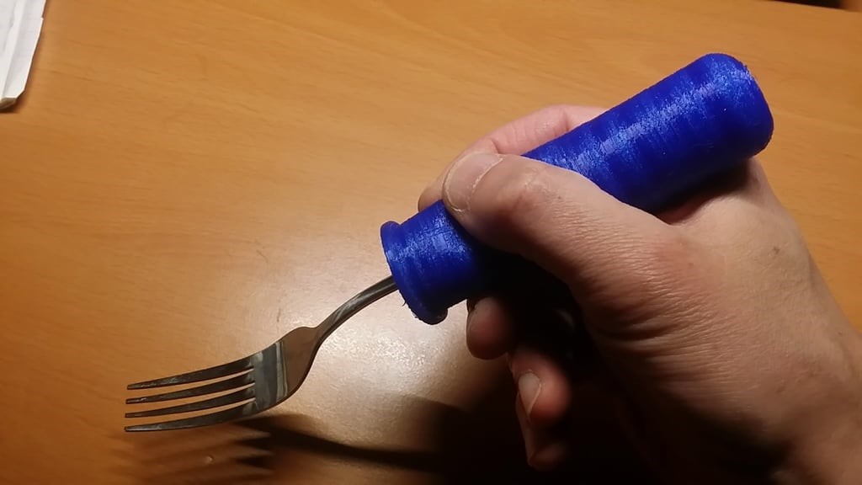

3D printed handle for flat metal fork/spoon/knife. Must be printed in a soft material like Ninjaflex, where infill density will affect the overall rigidity of the handle.

|  |  |
| --- | --- |
| **Requirements Met** | **Requirements Unmet** |
| G01, G02, G03, G04, F02, F04, NF01 | F01, F03, NF02 |

#### Useful Design Features

Soft material makes the handle compatible with a wide variety of utensil handles and makes the outer shell conform to the user’s grip.

# Working Notes

Students who worked on this project wrote digital notes of the development process. Screenshots from each student’s working notes have been inserted below.

## Handover from Fall 2022

## Progress & Handover from April 2024

## Progress from December 2024

